Testing Plan Report

Group 19

**Validation test**

* Requirement of this project
  + Keep the record of the students.
  + Provide a functionable login system for all users.
  + Allows teachers to view and update a students’ academic record.
  + Allows students to view their own academic record and update their personal information.
* Successful result
  + Perform correctly using different roles of users, including student, teacher and admin test cases
  + All functions of different roles should be working.
  + Meet all requirements.

Case 1 Sign up/log in account and load in homepage successfully

First, there are some user-account requirements:

username: S1111111( 1 letter + 7 digits (student type user))

password: 12345678(8 digits)

After a successful sign up and login in S1111111(student.homepage)

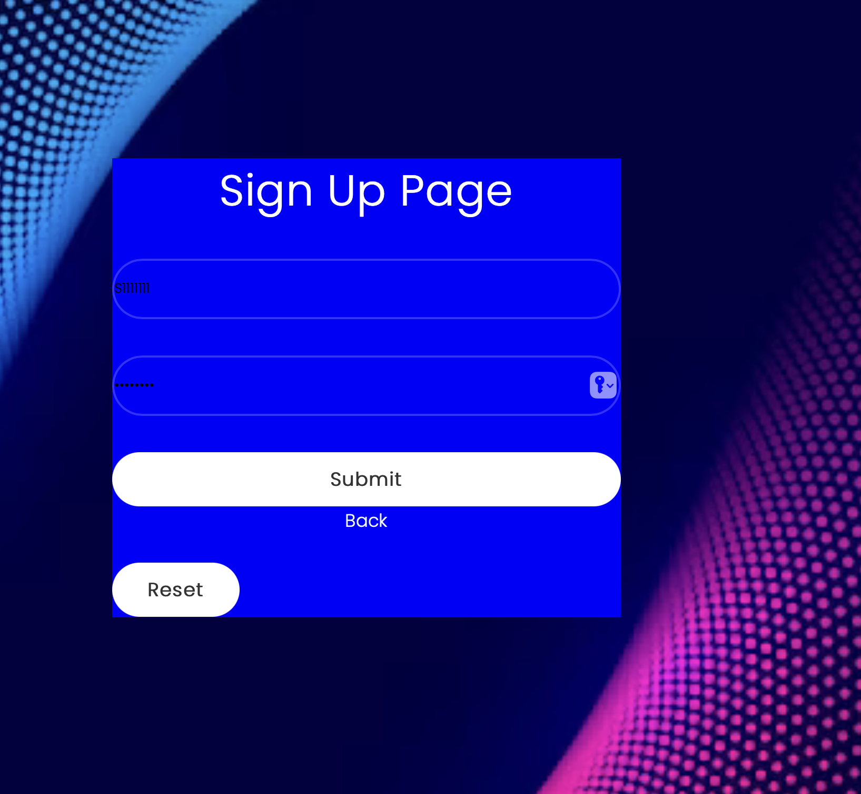

Moreover, in aspect of teacher and admin roles, it will direct into different version of home pages as below:

Teacher user home page:

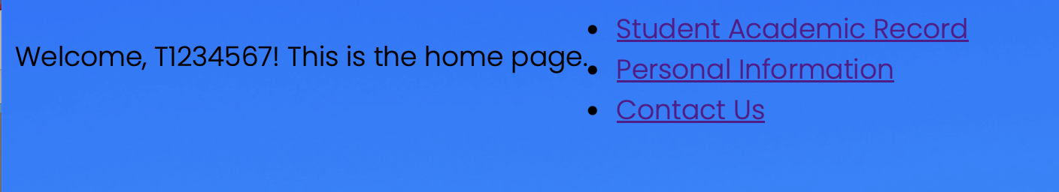

Admin user home page:



Case 2.1 View student academic record page successfully(students’ view)

Show the correct information of student academic record as below:

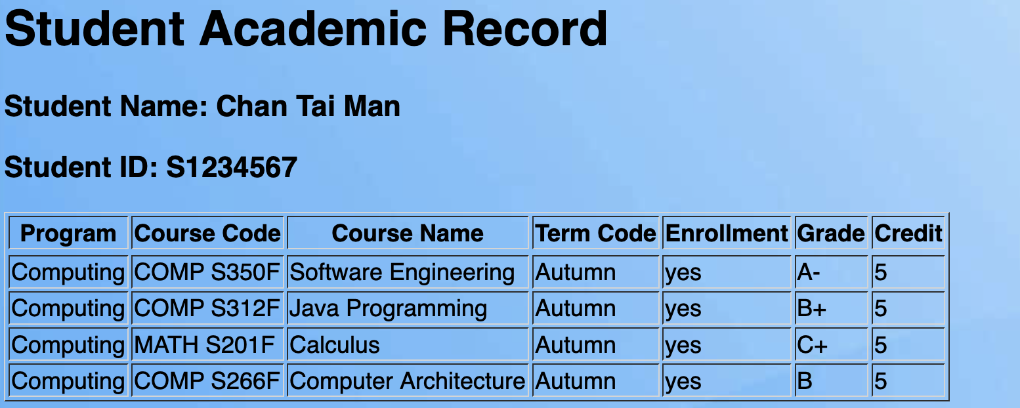

Case 2.2 View student academic record page successfully(teachers’ view)

Show the correct information of list of student record with the same study programs, which is referred to the program taught by the teacher as below:

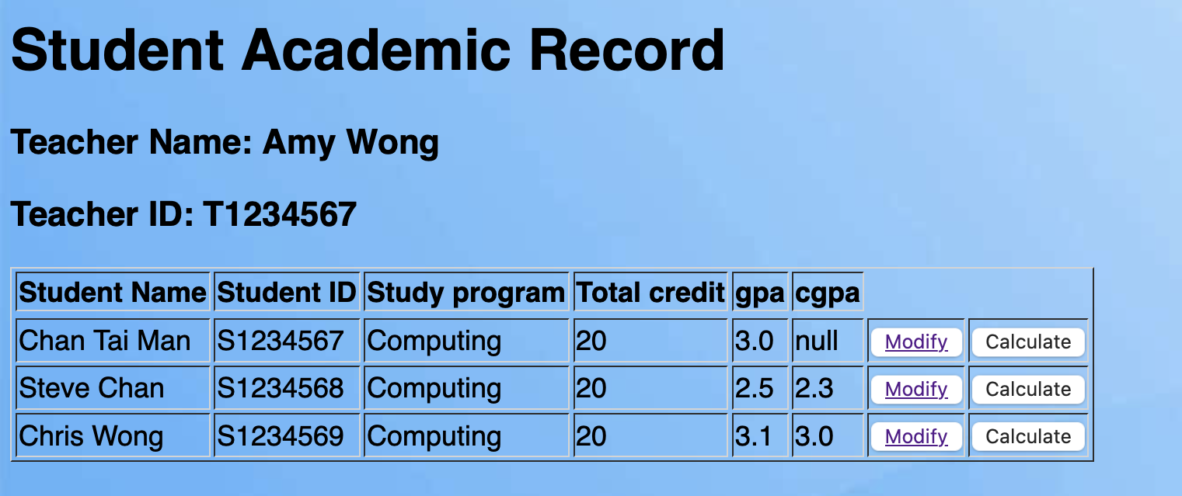

By clicking the modify button, it can show that student record and update the latest version of gpa and cgpa respectively:

However, there seems to be some unfixed sql query problems in the update_record_action.jsp that specifies the conversion of datatype of gpa and cgpa in html and mysql. Therefore, the modify function is not completed.

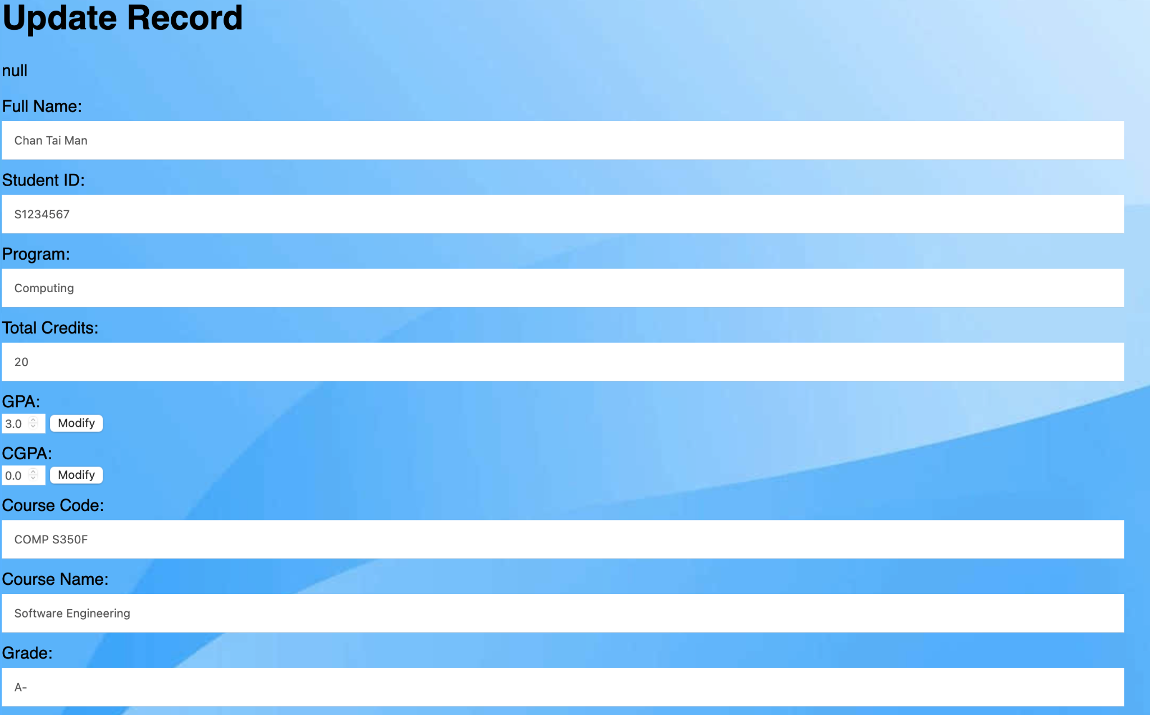

Case 3.1 View personal information page successfully(students’ view)

Show the correct information of student’s personal information as below:

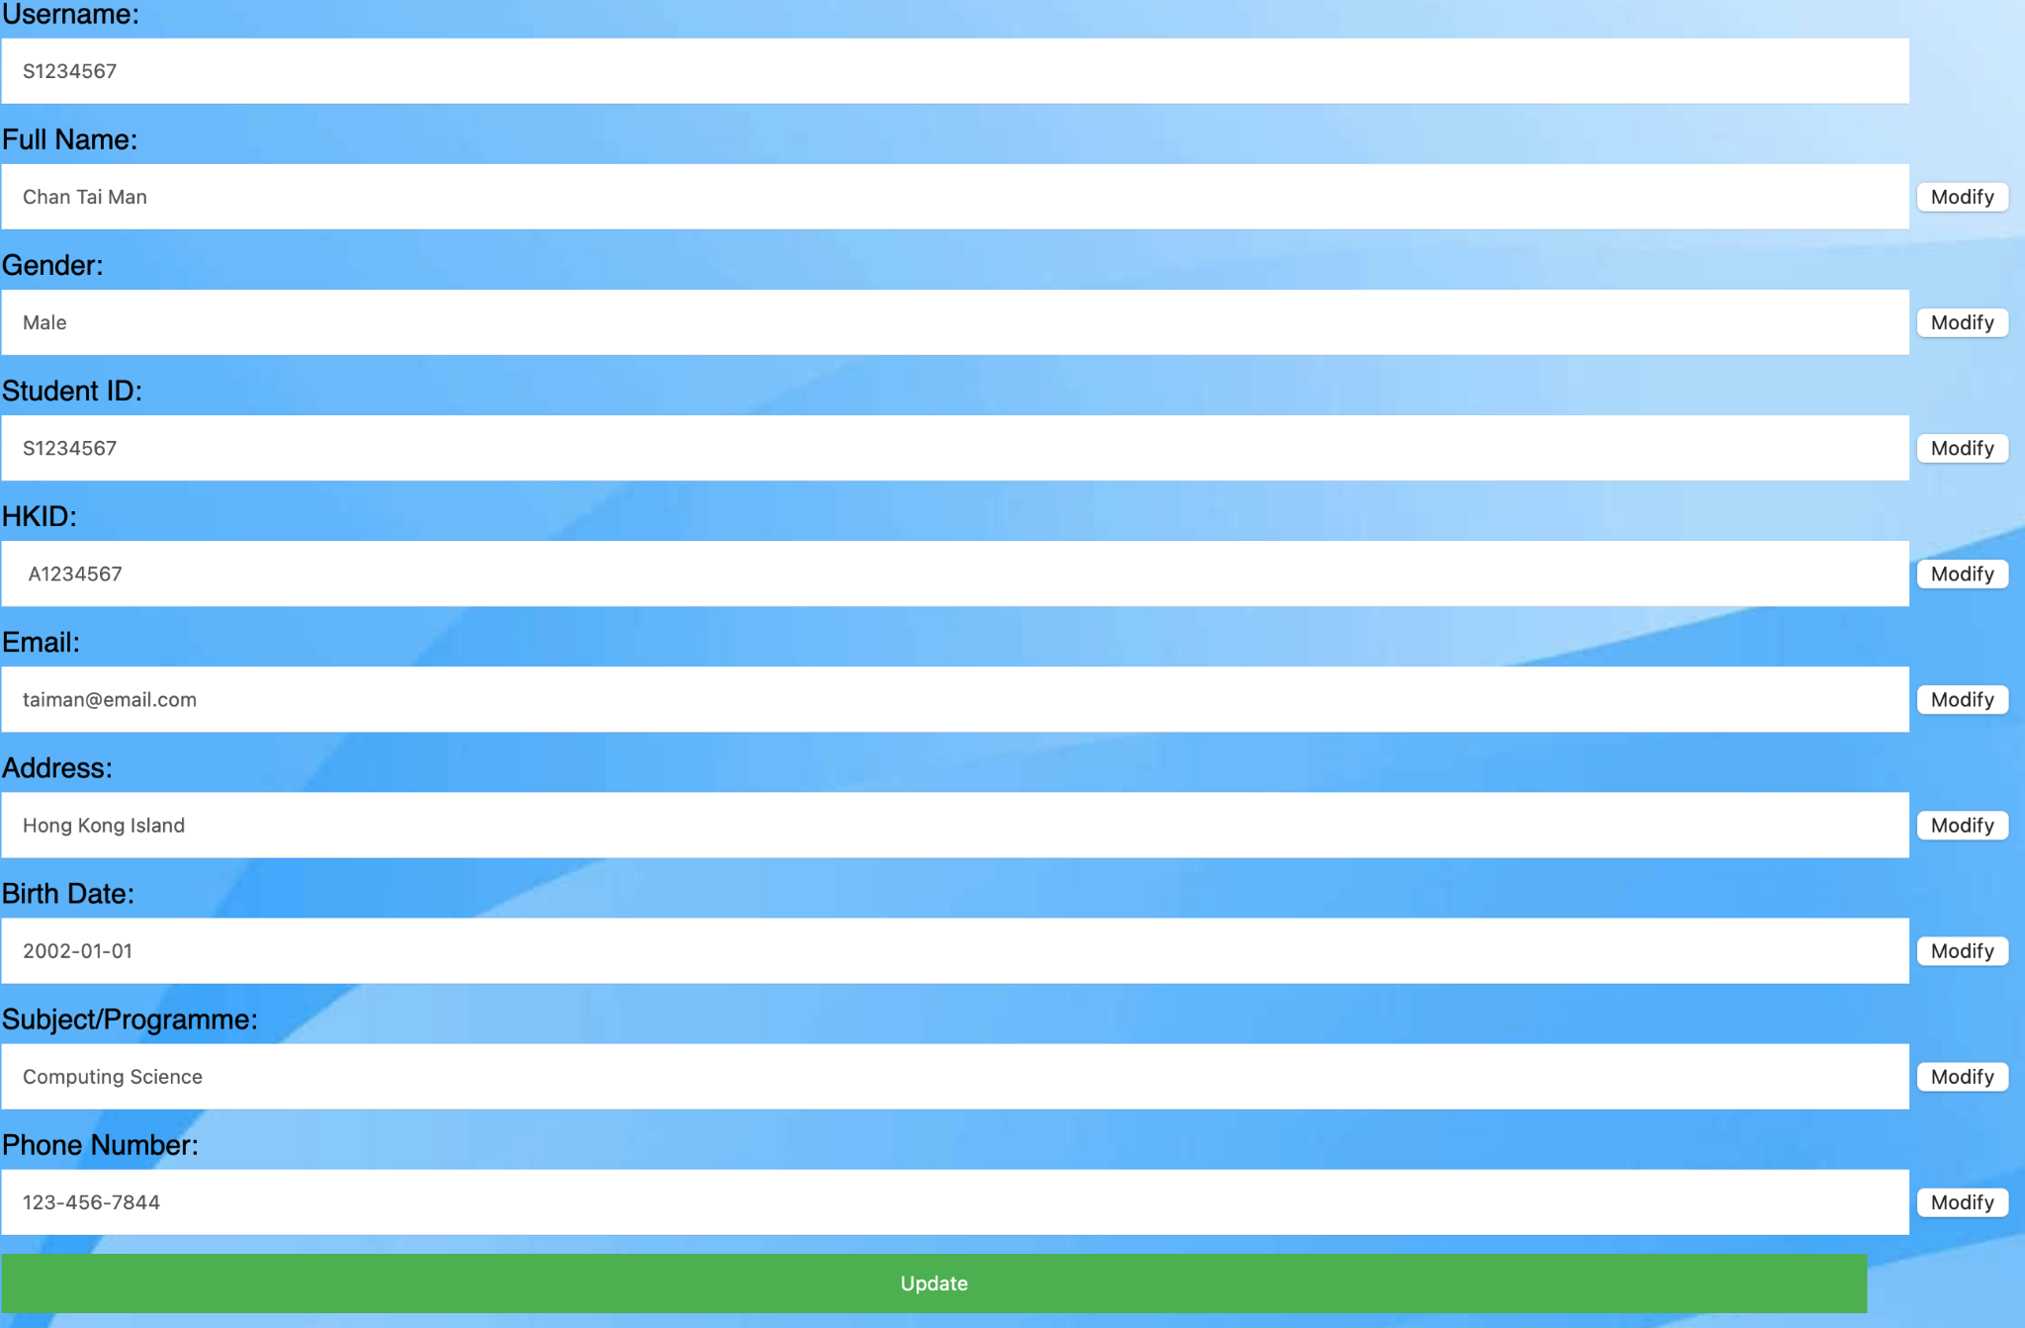

If the user clicks on the modify button of each row, and click update. When it successfully update the information in database, it will show the success message as below:

Case 3.2 View personal information page successfully(students’ view)

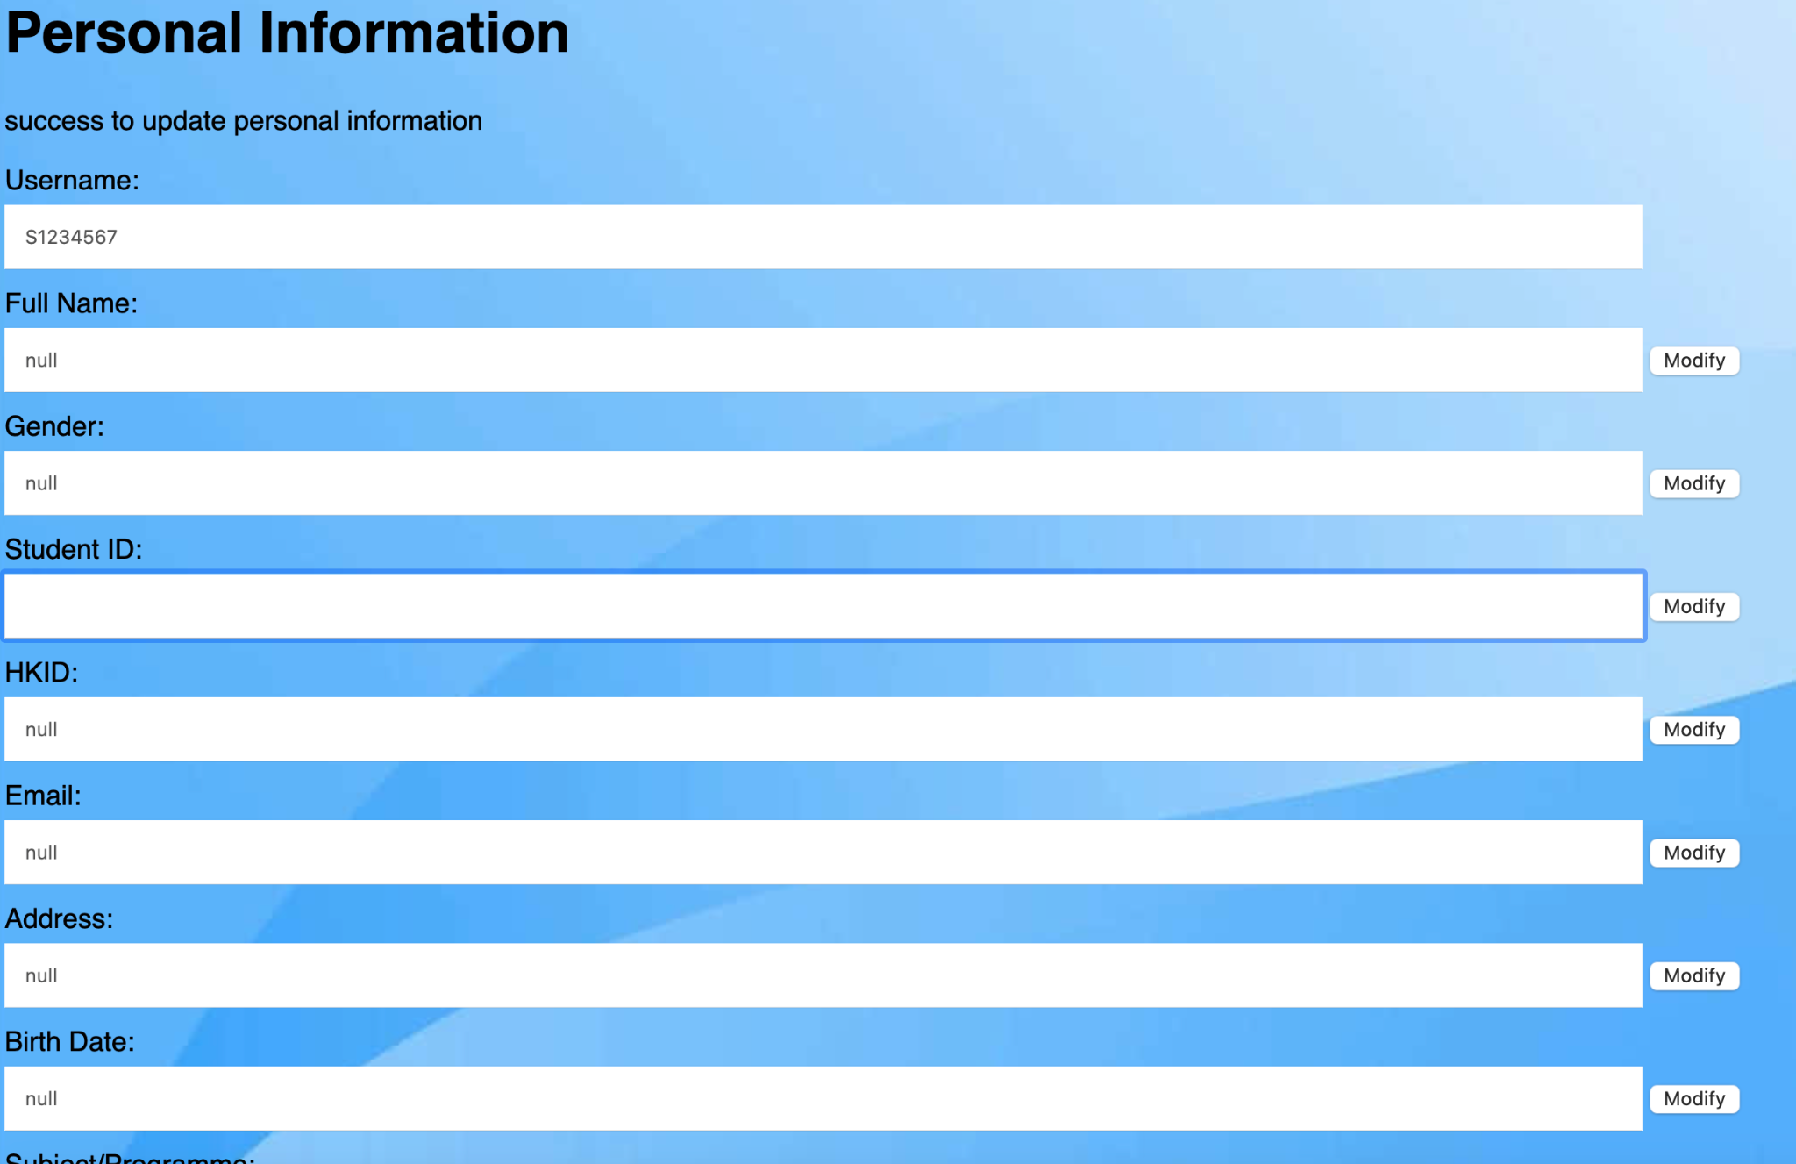

Then load into the personal.jsp again to show the updated information:

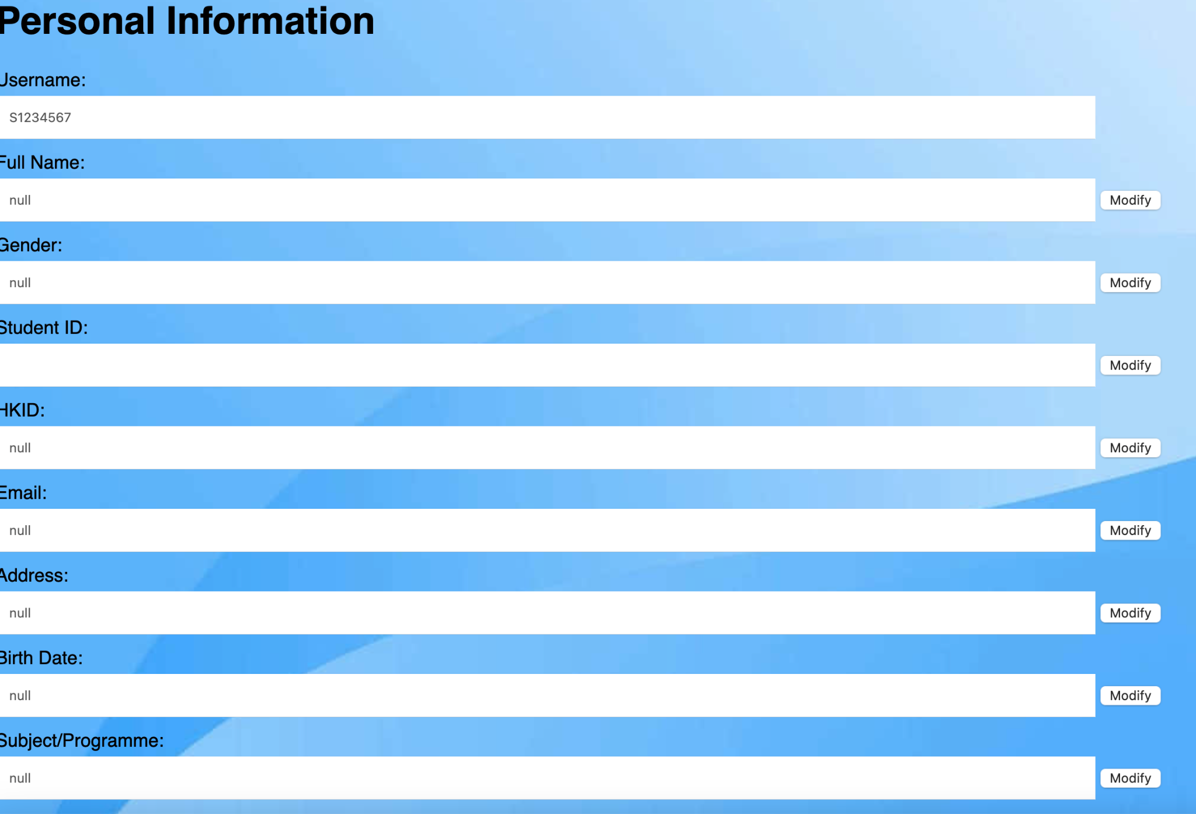

However, there are still some problems with updating the queries in which it just successfully updates when clicking on the modify button of student id. Otherwise, it will show the error message about mysql exception in case 3.2 in defect testing.

In addition, with teachers and admins user-account will also perform similar technique as well as:

Teacher’s personal information

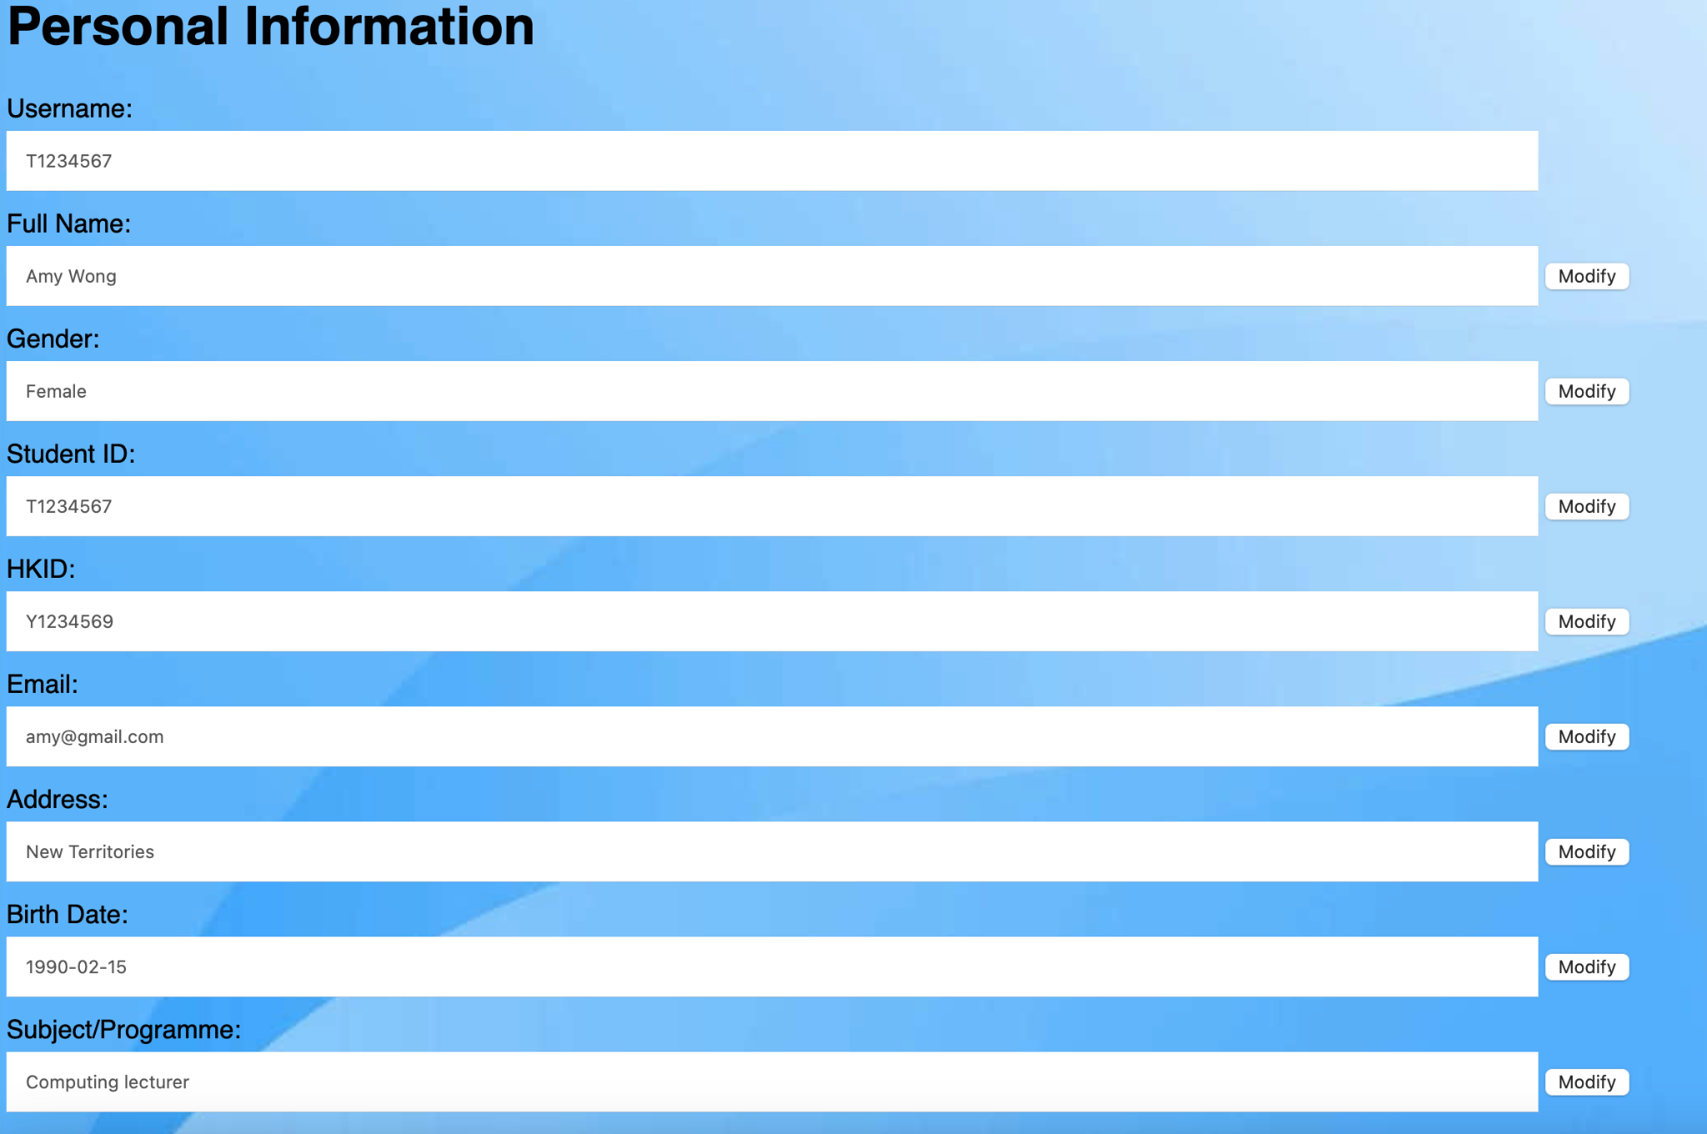

Admin’s personal information

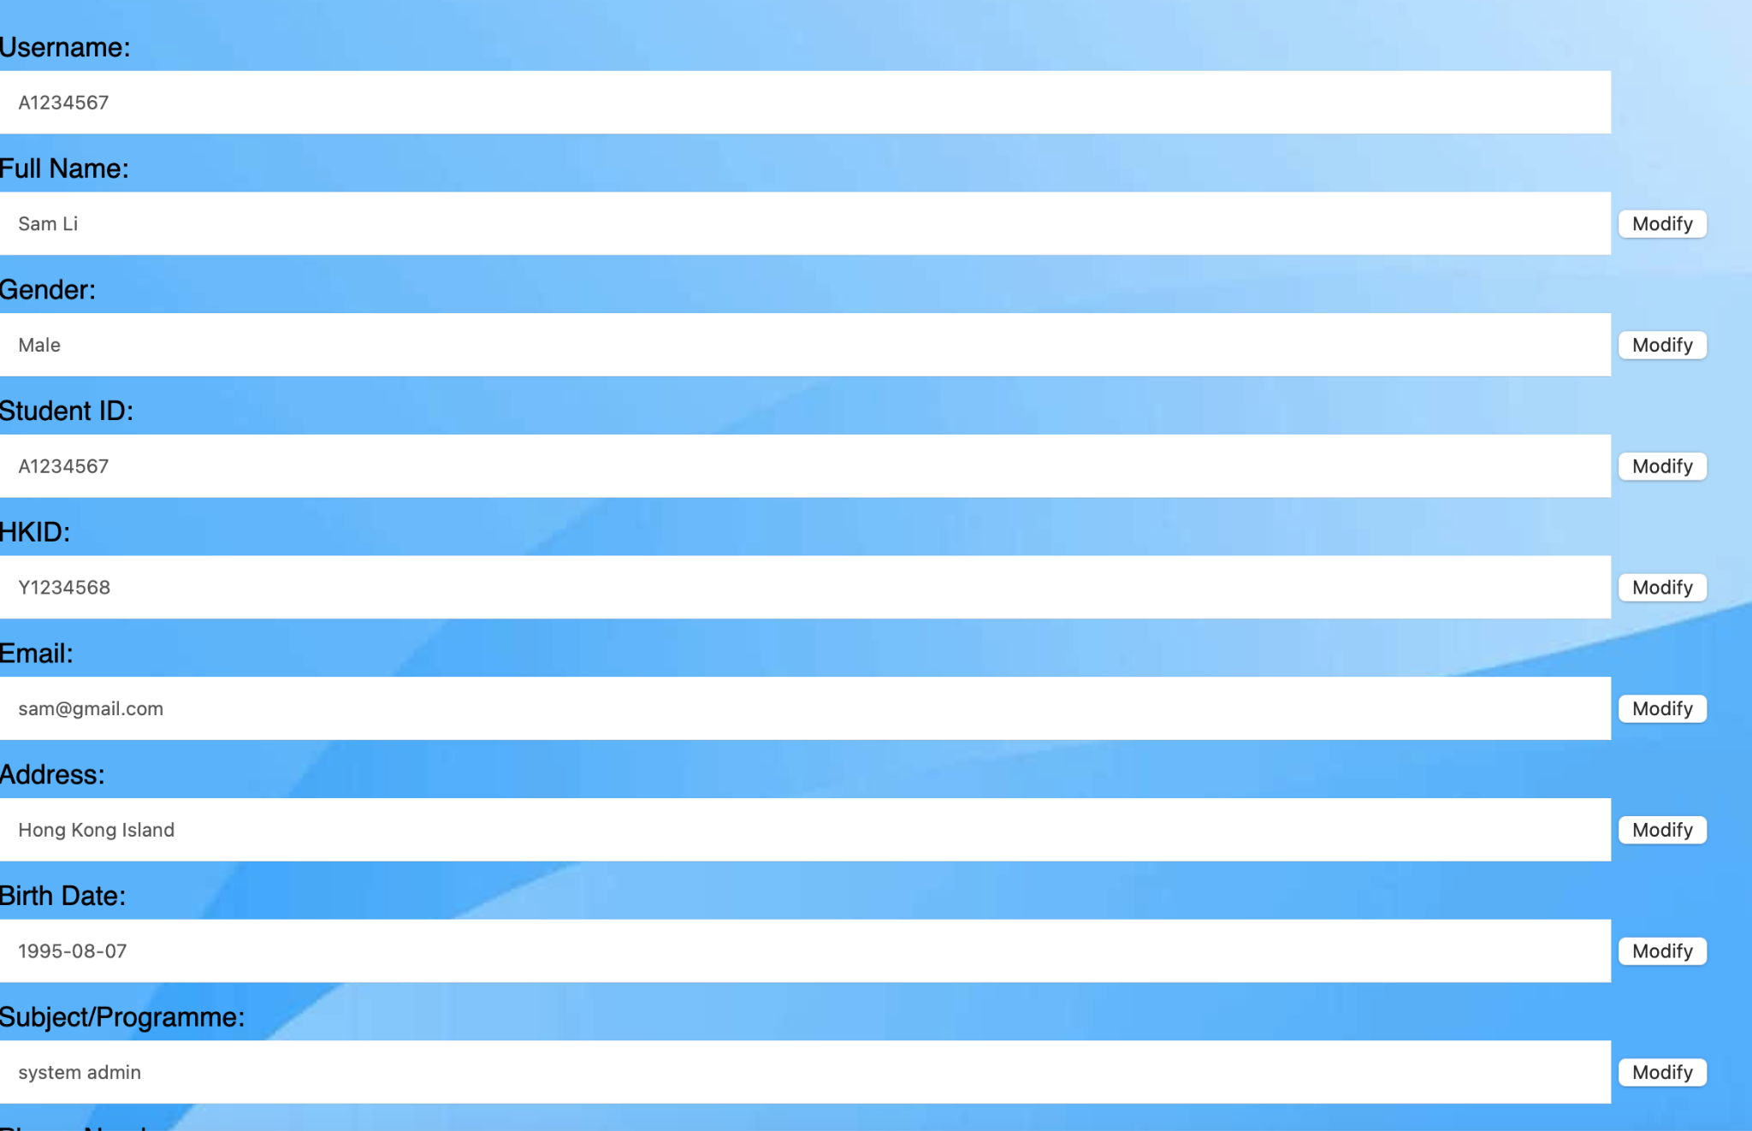

Case 4 View user information in admin page successfully(admin’ s view)

If the admin enters the admin page, it will show all user information with user id,full name, email, role(subject), register date.

Also, show which user has incomplete information with registration. However, the modify function is incompleted in the update_admin.jsp.

Administration page show below:

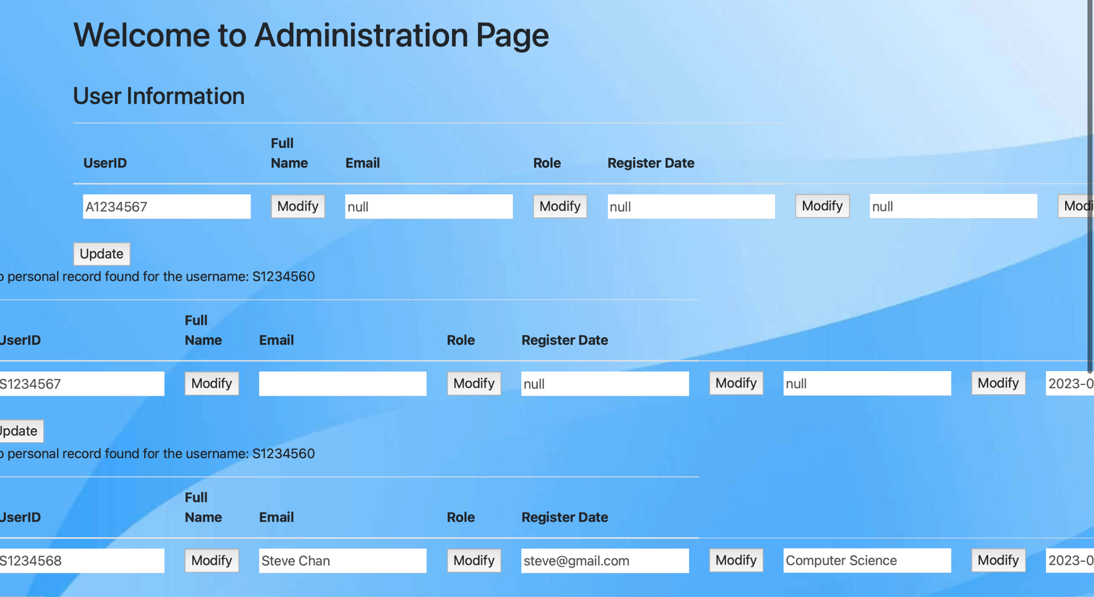

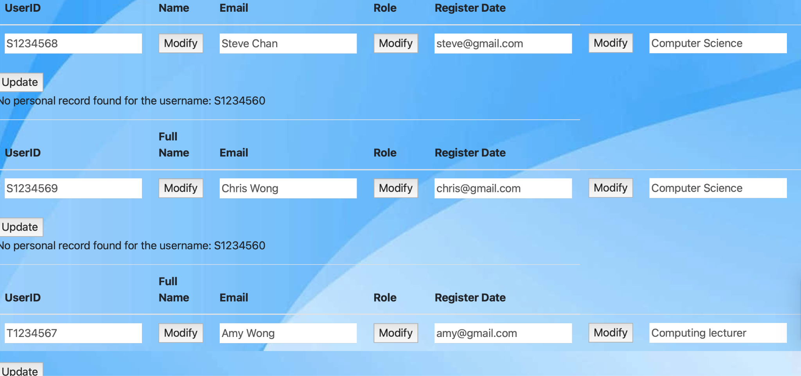

**Defect testing**

* Faults or defects in the software
  + Unit testing that update students’ academic records may contains error
  + Experience of common problems arise
* Successful result
  + Perform correctly when incorrect input at the login page
  + Found defects using unit testing

Case1 Create a user account and login an account (unsuccessful)

The user must create an account in a format of

1. username(started with a letter ‘S’,’A’,’T’ + 7 digits(0-9))
2. password with 8 digits(0-9)

Otherwise, login-error appears in case A and case B as below:

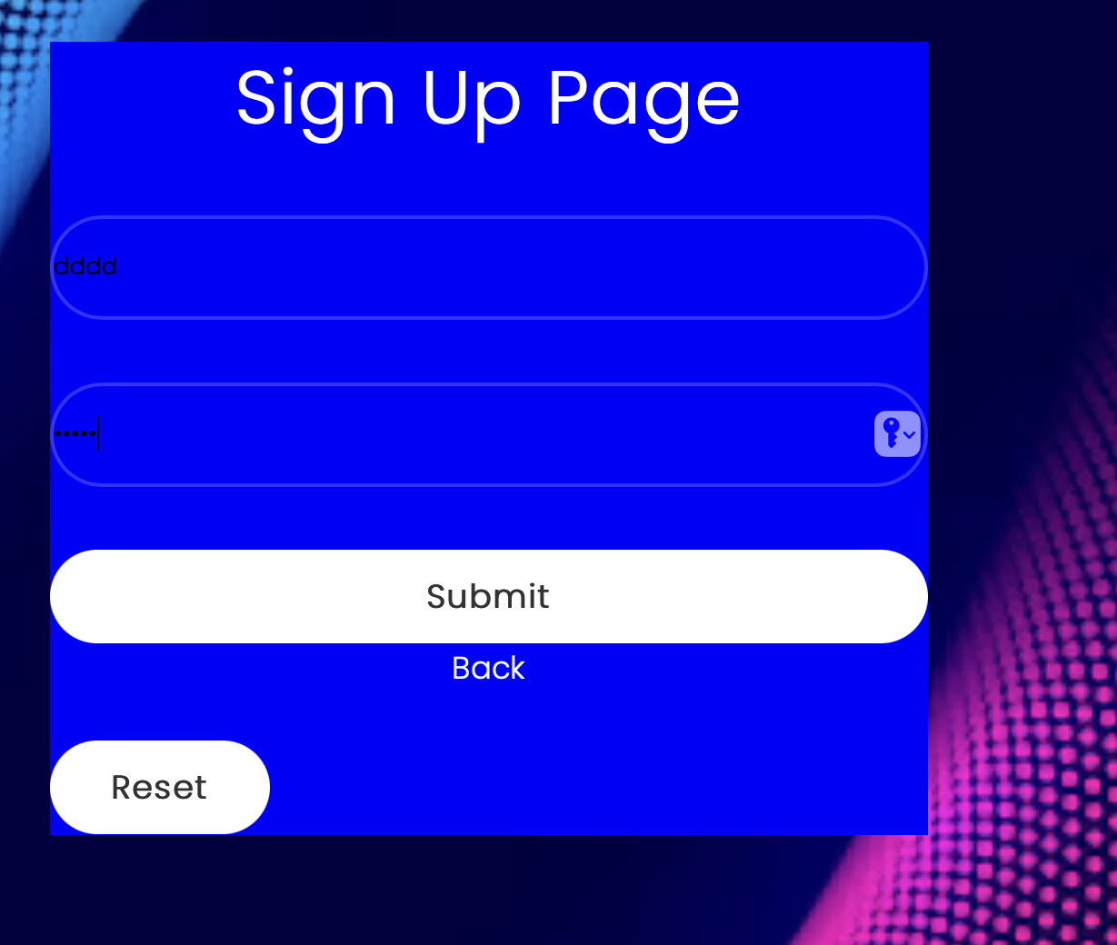

Case A

Username: dddd

Password: ****

The browser will not allow users to create an user account.

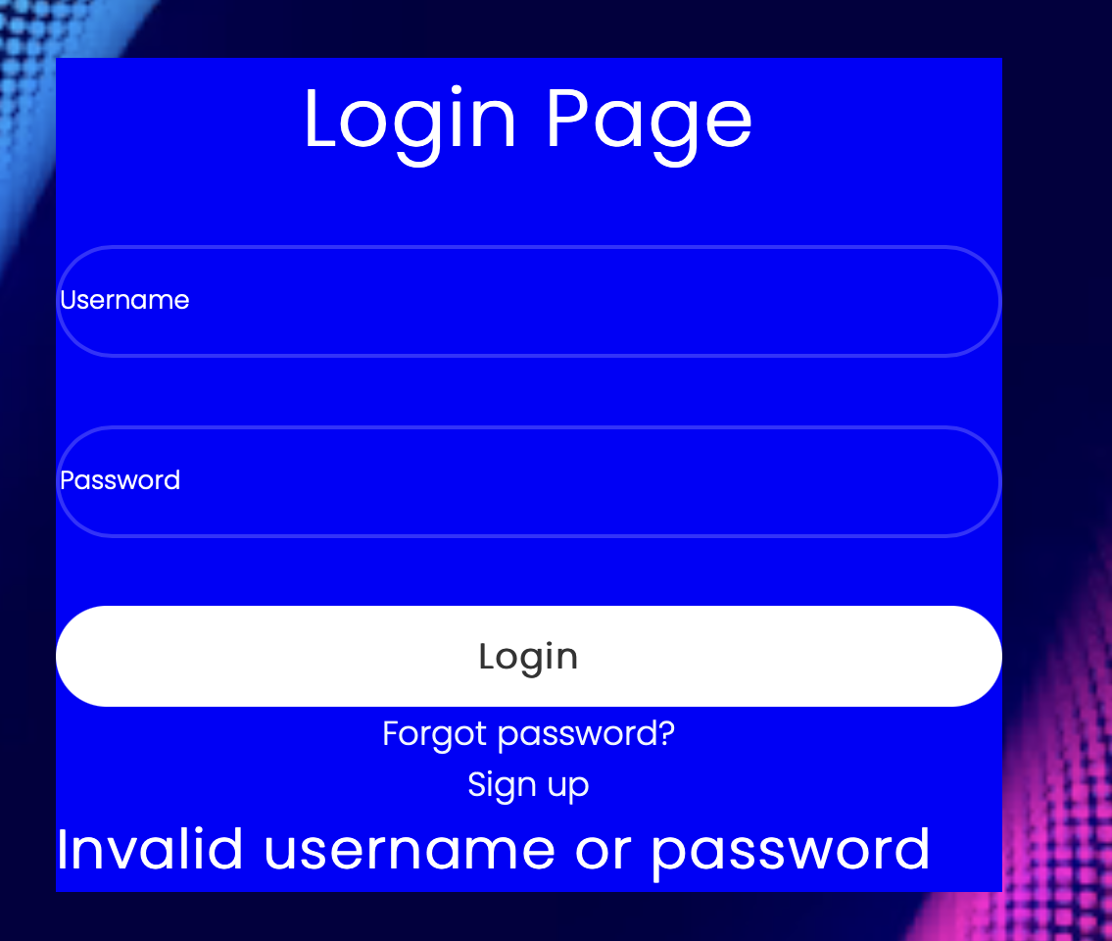

Case B

Username: (no input)

Password: (no input)

Also, it will show the invalid username and password message if the user types incorrect username or password as above includes blank value.

Case 2.1 View student version page unsuccessfully ( students’ view)

If the student username is not found in the student tables from database, the error message will show as below:

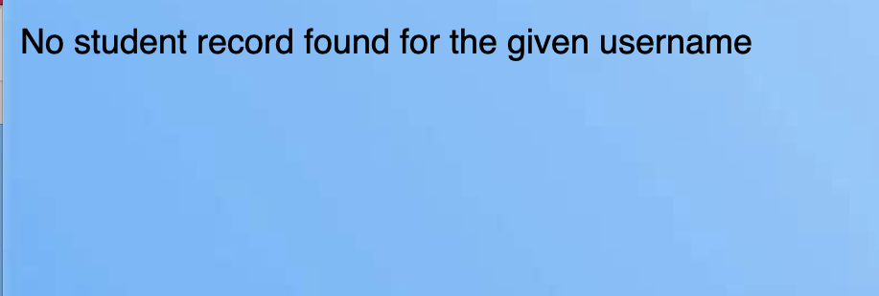

Case 2.2 View student version page unsuccessfully(teachers’ view)

If any student is matched with the program of that teachers used, no student record will show below:

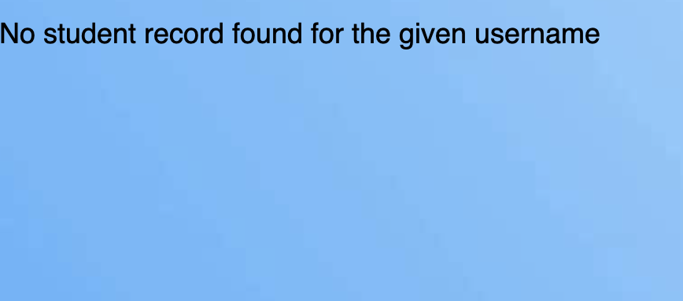

Case 3.1 View personal information page unsuccessfully(students’ view)

If the student is not found in the database with the table named personal,it means there is no personal record for that student and the error message shows below:

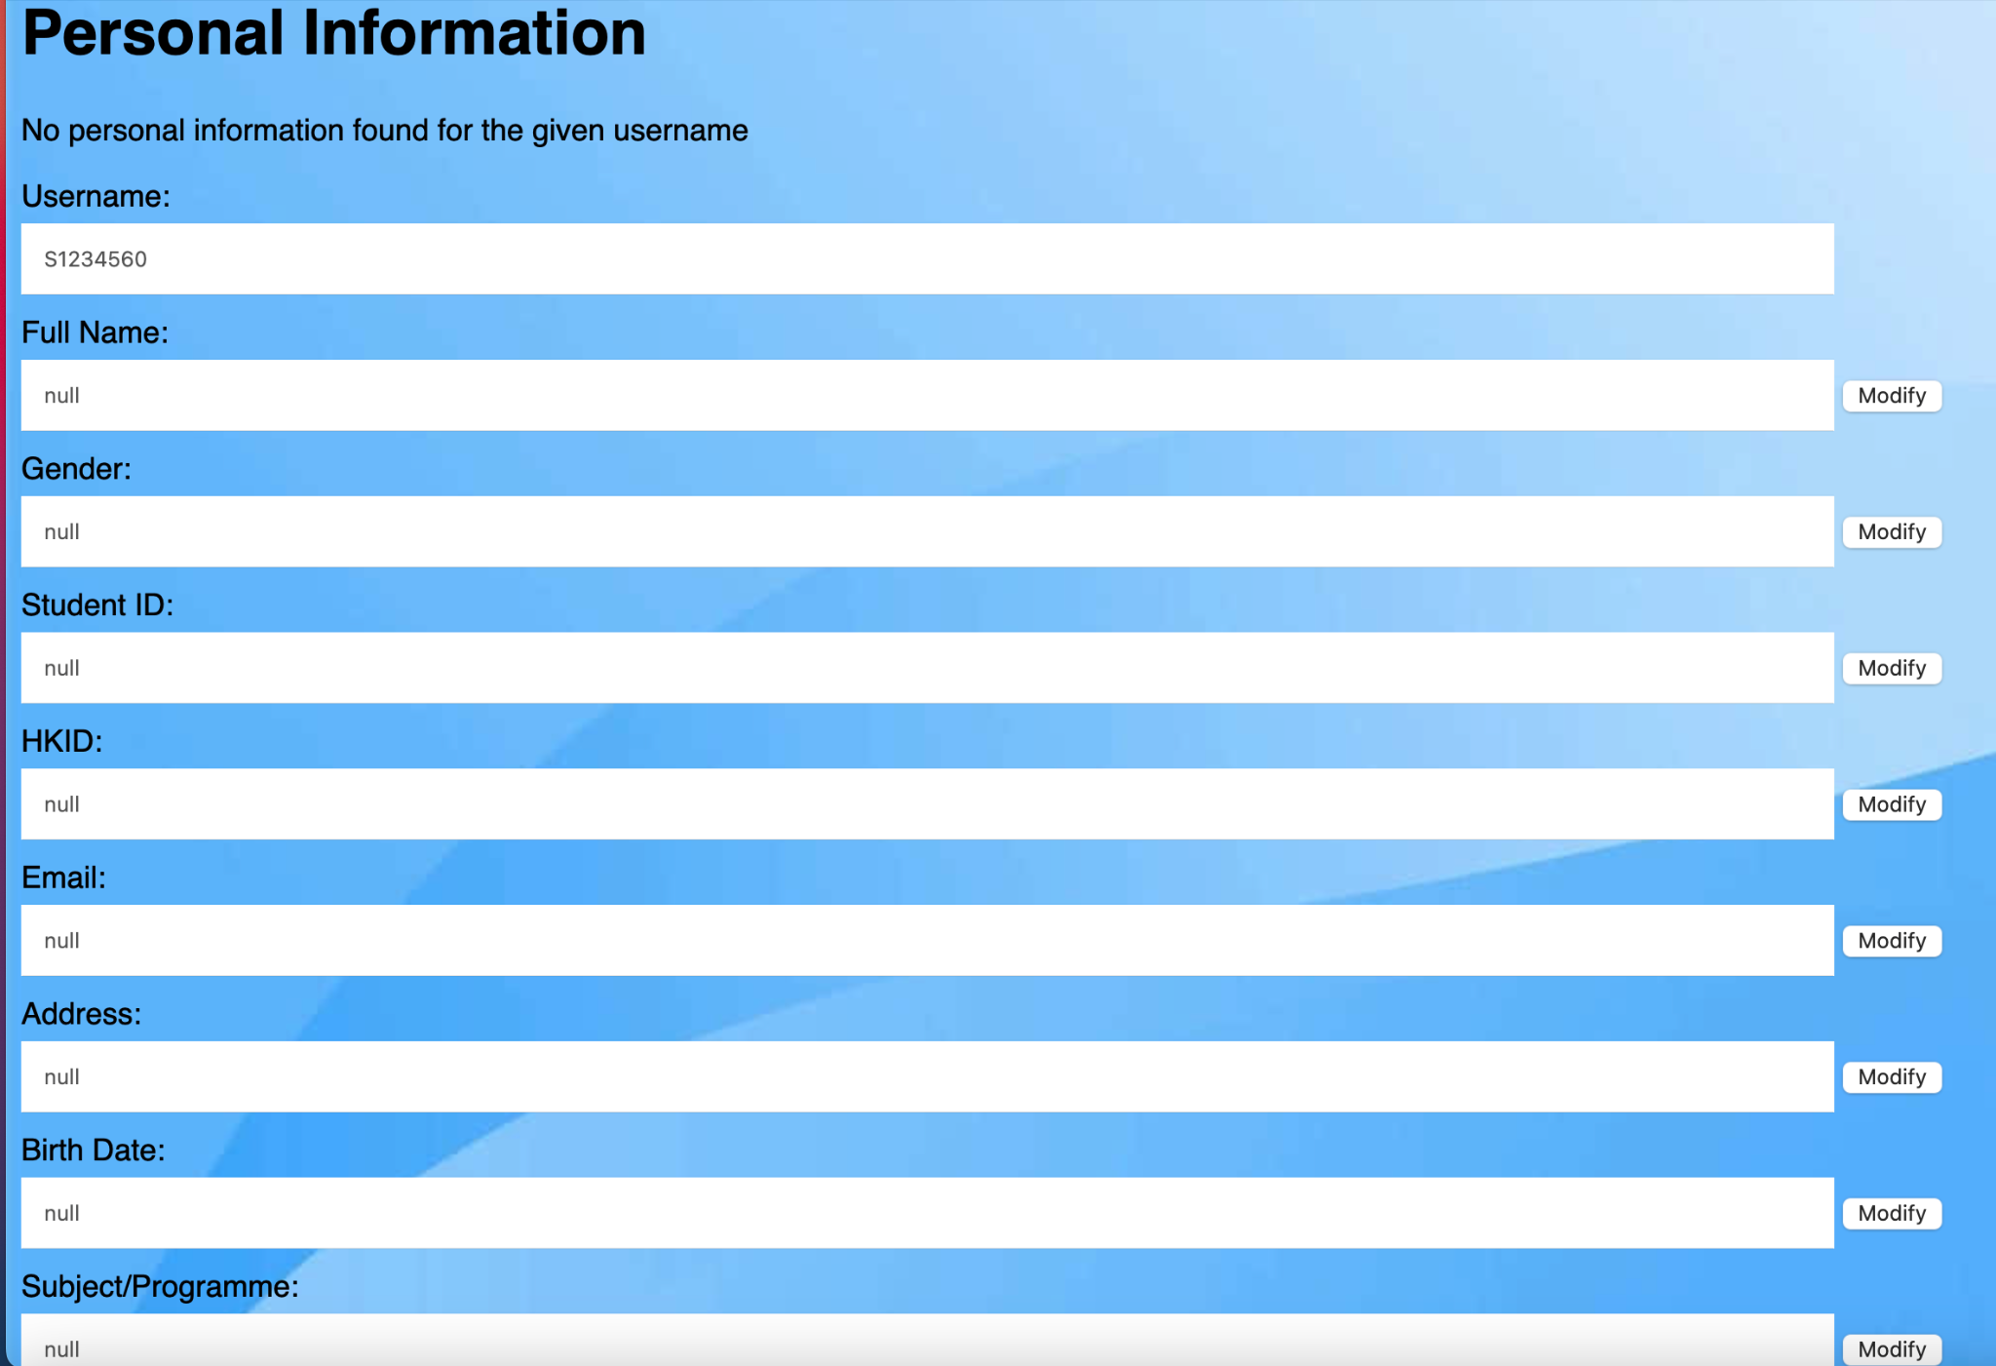

In which similar to teachers and admin cases.

Case 3.2 Update personal information page unsuccessfully(students’ view)

The error messages will be shown below:

